Dr. Lori Ernsperger, Ph.D., BCBA-D

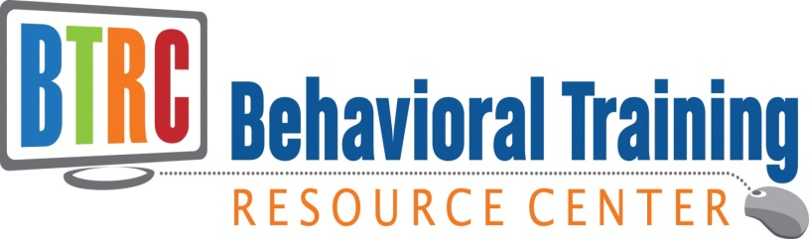

Dr. Ernsperger is Executive Director of Behavioral Training Resource Center, LLC, and a Board Certified Behavior Analyst (BCBA-D) with over 30 years of experience working in schools as a classroom teacher, administrator, behavior specialist, and educational consultant. Dr. Lori provides professional development and conference workshops to school professionals on a variety of topics to bridge the gap from research to evidence based practices for the classroom Dr. Lori has authored the following books:

- Keys to Success for Teaching Students with Autism,
- Just Take a Bite: Easy Effective Answers to Food Aversions and Eating Challenges,
- Girls Under the Umbrella of Autism Spectrum Disorders and
- Recognize, Respond, Report: Preventing and Addressing Bullying of Students with Special Needs.

Training Topics
Don’t see a topic that meets the unique needs of your school or agency?
Contact Dr. Lori for more training topics.
Drlori@cox.net

- Don’t Know Much About ABA? The 411 on Implementing ABA In a Variety of Settings
- Proactive Strategies for Preventing and Addressing Challenging Behaviors In The Classroom
- Implementing Evidence Based Instructional Methods,
- Practical Strategies for Teaching Students with ASD Across All Settings,
- How to Get your Kids to Eat: Strategies for Addressing Food Aversions and Eating Challenges,
- Girls Under the Umbrella of ASD: Strategies for Addressing Life’s Challenges,
- Results Driven Accountability: Designing and Implementing Easy and Effective Data Collection Methods and Progress Monitoring for the Classroom,
- The 3 R’s to Bullying Prevention: Recognize, Respond, and Report

Description
All training sessions and conference workshop are highly engaging with practical strategies to use immediately in the classroom. Dr. Lori utilizes interactive modeling, hands-on practice, and video clips throughout the presentation.

Proactive Strategies for Preventing and Addressing Challenging Behaviors In Schools
Individuals with disabilities can often exhibit a variety of problem behaviors that interfere with their learning and the school environment. Positive behavior programs and reinforcement assist the individual in learning new skills and benefiting from an educational program. In this workshop, participants will examine the functions of behavior and identify proactive strategies for teaching replacement skills and regulating antecedents. Participants will review the steps for conducting a functional behavior assessment and write a behavior intervention plan. Dr. Lori will provide evidence based strategies for addressing problem behaviors. This workshop will also provide practical strategies for managing problem behaviors in a variety of settings including the home and school.

Identifying Evidence Based Instructional Methods for Individuals with Disabilities
This session will review the current research supporting evidence based methods that can be implemented in a variety of settings including school and home. Participants will review the principles of applied behavior analysis and discrete trial teaching, as well as additional interventions such as visual supports and social skills training. Videos, hands-on activities, and documentation samples are provided to enrich the workshop.

Practical Strategies for Including Students with ASD in All Settings
Increasing numbers of students are being identified with Autism Spectrum Disorders. Dr. Lori will engage you in a highly interactive and fast-paced seminar addressing the many questions and concerns you have as a special education teacher, general education teacher, paraprofessional or therapist who works with these students. Participants will review the characteristics of this special population and identify key elements for success. Dr. Lori will share successful techniques and strategies for increasing learning and promoting positive behavior. She will give you ready-to-implement ways to develop predictable schedules, organize the environment, teach social skills, and manage problem behaviors. You will leave this seminar with dozens of ideas and strategies to help you make a real difference in your student’s learning.

How to Get your Kids to Eat: Easy, Effective Answers to Food Aversions and Eating Challenges
Children with Autism Spectrum Disorders and Developmental Disabilities often experience pervasive and alarming food aversions and eating challenges. Researchers estimate that 75% of children with developmental delays and 45% of typically developing children experience eating challenges. This workshop will review the physiological, sensory, and behavioral reasons for food selectivity and provide a comprehensive treatment program for increasing food selections and answering eating challenges at home and in school. Participants will review the characteristics and causes for resistant eaters. This workshop will also include demonstrations and hands-on techniques for addressing eating challenges.

The 3 R’s To Bullying Prevention for Students with Autism Spectrum Disorders: Recognize, Respond, and Report
Bullying was once a silent epidemic which was endured by millions of children on a daily basis. The attitude “kids will be kids” was just part of normal childhood development. Today, bullying in schools is being recognized as a national problem for all students including children with autism spectrum disorders (ASD). Dr. Ernsperger will provide research and specific strategies in order for parents and professionals to create a safe educational environment where all students can achieve.
www.stopbullyinginschools.net

Results Driven Accountability: Designing and Implementing Easy and Effective Data Collection Methods for The Classroom
Progress monitoring and data collection are integral parts to an effective educational program for students with disabilities. Dr. Lori will demonstrate easy to implement data collection methods to demonstrate student success. Dr. Lori provides sample data collection forms and simple tools for collecting data. This workshop targets behavioral data collection as well as strategies for analyzing the data for results driven accountability. KISS= Keep is Short and Simple is the goal for this workshop.
Girls Under the Umbrella of ASD
During this workshop, the Dr. Lori will highlight the core gender differences between boys and girls on the autism spectrum. The focus of this presentation is to review the research on girls with autism spectrum disorders and provide effective insights and strategies for addressing specific issues which include the diagnosis, educational planning, friendship making, bullying prevention, dating and safety, and self-advocacy skills.

For more information:
www.loriernsperger.com
www.behavioraltrainingresourcecenter.com

